Athletic Fees

The Athletic Fees for the 2017-2018 school year will be:

$175 for the first sport
and $150 for the second and $150 for the third sport.
Crew fees are TBA

The following sport will have additional fees for uniforms they purchase and keep

- XC/Track- $60 for briefs and tank
- FH/Lax- $15 for socks Pinnie $20
- Soccer socks $15
- Swimming- suit and cap (fee TBA usually $65-$75)
- All sports- mandatory warm ups $85 or $91
*Need info by Aug.22 for fall athletes
- Optional clothing available from Mrs. Columbro
  - Long sleeve black microfit $20
  - Mount Tumbler $5
  - Long Sleeve White Cotton Athletic $20

- Online store opening in August
Check the Mount website on Aug. 22

Warm up order 2017-2018

Name___________________________ Sport ______________or Athletics (multi sports)

Packet #1 ½ zip jacket and pants $85.00

Jacket size XS S M L XL

Pant size XS S M L XL

Packets #2 full zip and pants $91.00

Jacket size XS S M L XL

Pant size XS S M L XL

Optional:
Rain Jacket size $85 S M L XL

Packet #1 or #2 is MANDATORY for all sports.

Check payable to “MSJA”

Samples available in Mrs. Columbro’s office

Optional Clothing Order Sheet

Name_______________________________________________________________________

Long sleeve black microfit $20 S M L XL
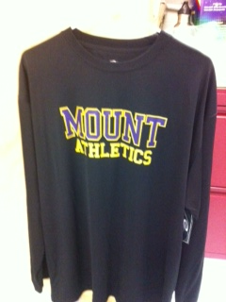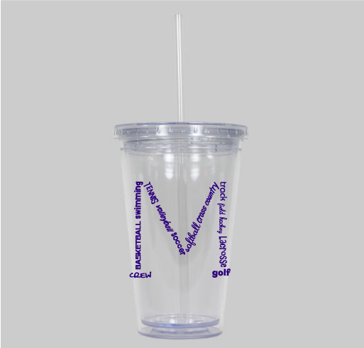

Mount Tumbler $5 Quantity _____

Mount White Long Sleeve T-shirt $20
Sizes: Adult S M L XL
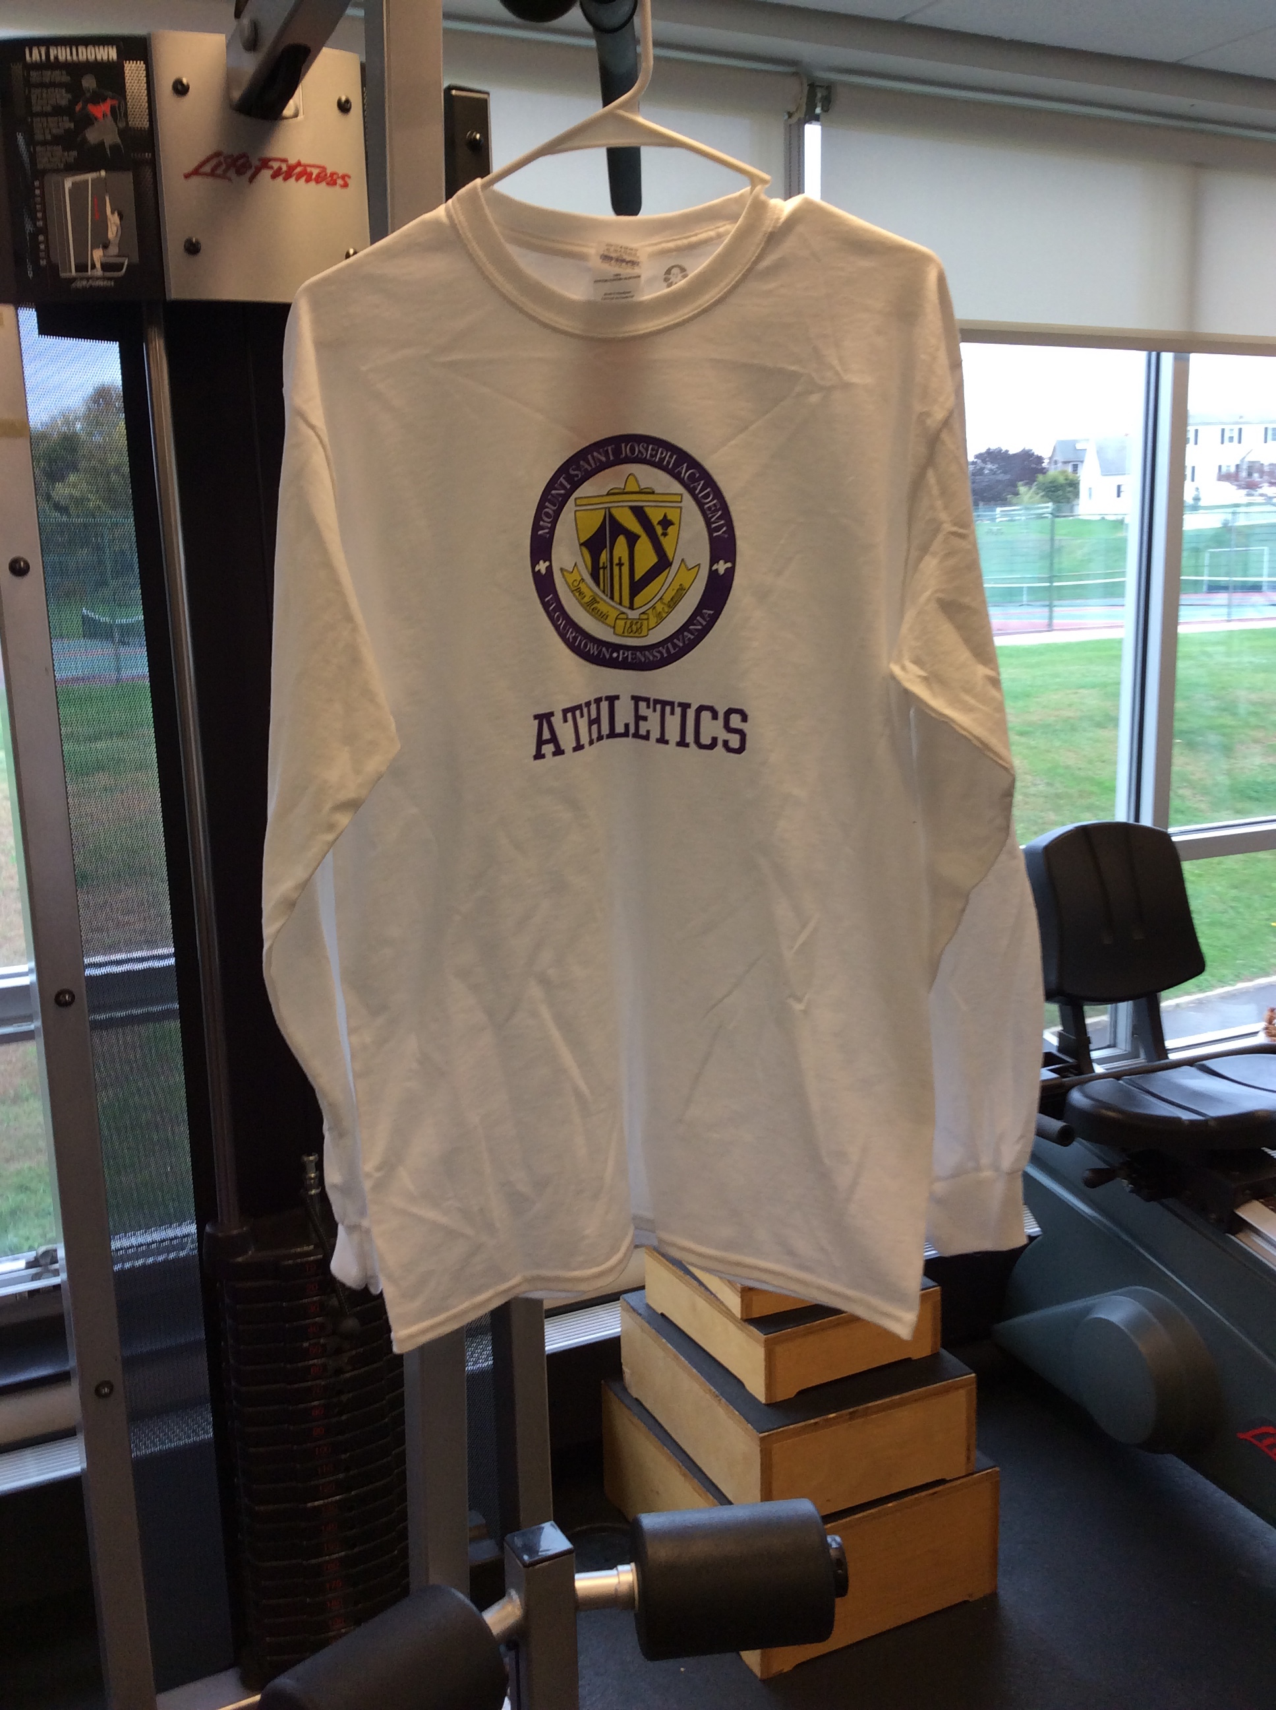

Check payable to MSJA

